Workforce Analysis

On-Demand Home Services in Kathmandu

Prepared for: Sriyog Consulting
Prepared by: Sadikshya Karki

Date: June 2026
Research Scope: Kathmandu, Nepal

1. Introduction
The on-demand home services sector in Nepal is experiencing a notable shift as urban households increasingly seek professional assistance for household maintenance, repair, personal care, and lifestyle services. This report presents a workforce analysis across 40 service categories identified as part of an on-demand home services market assessment. The objective is to understand the current landscape of service providers, examine the level of demand and competition in each category, and assess how well the existing workforce meets market needs.
The analysis draws on primary research conducted to identify and profile service providers operating in Nepal, including formal companies, app-based platforms, and informal or directory-listed suppliers. Each category has been evaluated on key parameters such as the number of providers found, the prevailing demand level, the intensity of competition, and the overall supply adequacy.

2. Scope and Methodology
This analysis covers 40 service or profession categories spanning home maintenance, personal care, technical repair, construction trades, and specialized lifestyle services. For each category, researchers identified available service providers through online searches, platform listings, and local directories. Providers were then classified into three types:
- Formal companies registered businesses operating in a structured manner
- App-based or platform-enabled providers workers accessible through digital service platforms
- Informal or directory-based suppliers individuals or businesses listed through local directories and social media
Each category was ranked by overall competitiveness and assigned a supply status label describing how well the current workforce meets consumer demand. Demand and competition levels were assessed as High, Medium, or Low based on the concentration of providers and observable market activity.

3. Service Category Overview
The following table presents all 40 service categories along with their respective provider counts, demand level, competition level, rank, formality breakdown, and supply status. This serves as the primary reference dataset for the analysis that follows.
Table 1: Service Category Overview
No. | Service | Providers Found | Demand Level | Competition Level | Rank | Formal Companies % | App or Platform % | Supply Status
1 | Deep Cleaning | 14 | High | High | 4 | 50% | 43% | Well-served
2 | Garden Care | 11 | Low | High | 6 | 73% | 18% | Sufficient
3 | Masonry Repair | 6 | High | Medium | 23 | 50% | 50% | Sufficient
4 | Plumbing Repair | 20 | High | High | 1 | 45% | 50% | Well-served
5 | Electrical Repair | 19 | High | High | 2 | 42% | 53% | Well-served
6 | Carpentry | 11 | High | High | 6 | 36% | 55% | Sufficient
7 | Washing Machine Repair | 8 | High | Medium | 19 | 50% | 50% | Sufficient
8 | EV Charger Installation | 4 | Medium | Low | 29 | 50% | 50% | Limited
9 | AC Services | 14 | High | High | 4 | 43% | 57% | Well-served
10 | Painting | 17 | High | High | 3 | 59% | 35% | Well-served
11 | Packing and Moving | 9 | High | High | 13 | 78% | 22% | Sufficient
12 | AirBnB Maintenance | 2 | Medium | Low | 38 | 100% | 0% | Limited
13 | Bridal Makeup | 11 | High | High | 6 | 18% | 9% | Sufficient
14 | RO Water Purifying | 6 | High | Medium | 23 | 50% | 50% | Sufficient
15 | Refrigerator Repair | 7 | Medium | Medium | 21 | 57% | 43% | Sufficient
16 | CCTV Services | 9 | High | Medium | 13 | 44% | 56% | Sufficient
17 | Modular Kitchen | 11 | High | High | 6 | 73% | 18% | Sufficient
18 | Home Renovation | 9 | High | Medium | 13 | 67% | 33% | Sufficient
19 | Pest Control | 11 | Medium | High | 6 | 64% | 36% | Sufficient
20 | Drywall Repair | 2 | Low | Low | 38 | 100% | 0% | Limited
21 | Salon at Home | 11 | High | High | 6 | 27% | 18% | Sufficient
22 | Tiling | 9 | High | High | 13 | 33% | 44% | Sufficient
23 | Chef at Home | 3 | Low | Low | 34 | 33% | 67% | Limited
24 | Home Automation | 2 | Low | Low | 38 | 100% | 0% | Limited
25 | Parqueting | 4 | Low | Low | 29 | 75% | 0% | Limited
26 | Indoor Planting | 4 | Low | Low | 29 | 50% | 0% | Limited
27 | Spa at Home | 5 | Medium | Medium | 25 | 60% | 20% | Limited
28 | Physiotherapy | 5 | Medium | Medium | 25 | 80% | 20% | Limited
29 | Handyman | 8 | High | High | 19 | 38% | 38% | Sufficient
30 | Massage Therapy | 4 | Medium | Low | 29 | 75% | 0% | Limited
31 | Water Tank Cleaning | 10 | Medium | High | 12 | 80% | 20% | Sufficient
32 | Aluminium Fabrication | 9 | Medium | High | 13 | 56% | 33% | Sufficient
33 | False Ceiling | 7 | Medium | Medium | 21 | 43% | 57% | Sufficient
34 | Computer Repair | 9 | Medium | High | 13 | 22% | 78% | Sufficient
35 | Geyser Repair | 5 | Medium | Medium | 25 | 40% | 60% | Limited
36 | Chimney Repair | 4 | Low | Low | 29 | 50% | 50% | Limited
37 | Tree Cutting and Pruning | 3 | Low | Low | 34 | 67% | 33% | Limited
38 | Septic Tank Cleaning | 3 | Medium | Low | 34 | 100% | 0% | Limited
39 | Pet Grooming | 5 | Low | Medium | 25 | 60% | 40% | Limited
40 | Lift or Elevator Repair | 3 | Low | Low | 34 | 67% | 0% | Limited

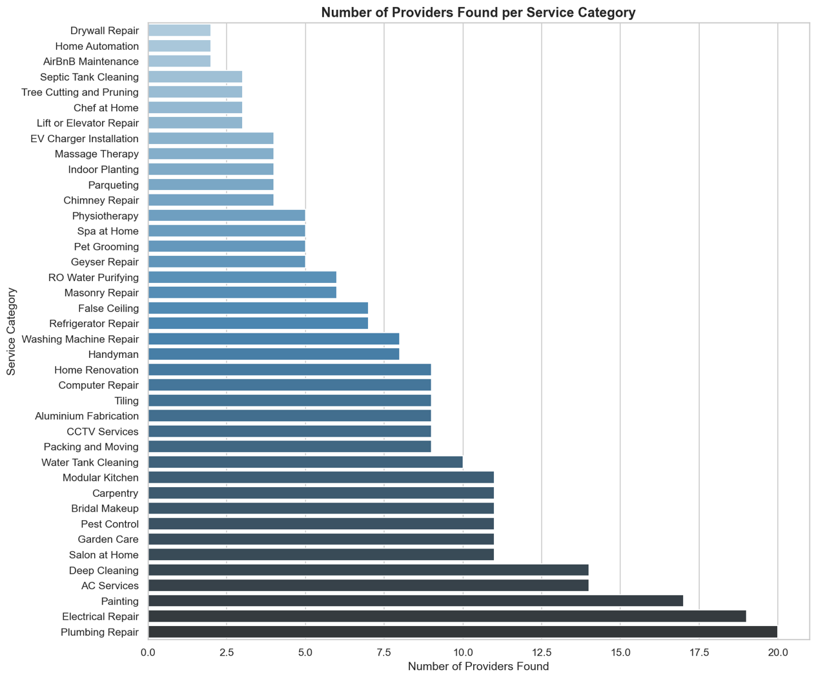
Figure 1: Number of Providers Found per Service Category
The chart above provides a visual summary of provider counts across all 40 categories, sorted from the most to the least supplied. Plumbing Repair and Electrical Repair lead the market with 20 and 19 providers respectively, while AirBnB Maintenance, Drywall Repair, and Home Automation sit at the bottom with only 2 providers each. The widespread across categories makes it clear that supply is far from uniform across the home services market.

4. Supply Status Distribution
An important dimension of this workforce analysis is understanding how adequately each service category is currently supplied. The supply status categories reflect whether the available workforce is sufficient to meet consumer demand in each area.
Table 2: Supply Status Distribution across 40 Service Categories
Supply Status | Number of Services | Percentage
Well-served | 5 | 12.5%
Sufficient | 19 | 47.5%
Limited | 16 | 40.0%

Out of the 40 categories analyzed, the findings by supply status are as follows:
- Well-served (5 categories, 12.5%): Plumbing Repair, Electrical Repair, Painting, Deep Cleaning, and AC Services. These are high-demand sectors where a mature and competitive provider base has developed, typically drawing on both formal companies and platform-enabled workers.
- Sufficient (19 categories, 47.5%): This group includes Carpentry, CCTV Services, Modular Kitchen, Home Renovation, Salon at Home, and others. Supply is reasonably adequate in these categories, though there is still room for quality improvement and geographic expansion.
- Limited (16 categories, 40%): Categories such as EV Charger Installation, Spa at Home, Physiotherapy, Geyser Repair, and Lift or Elevator Repair fall here. These represent either emerging services or niche trades that have not yet attracted sufficient formal workforce development.
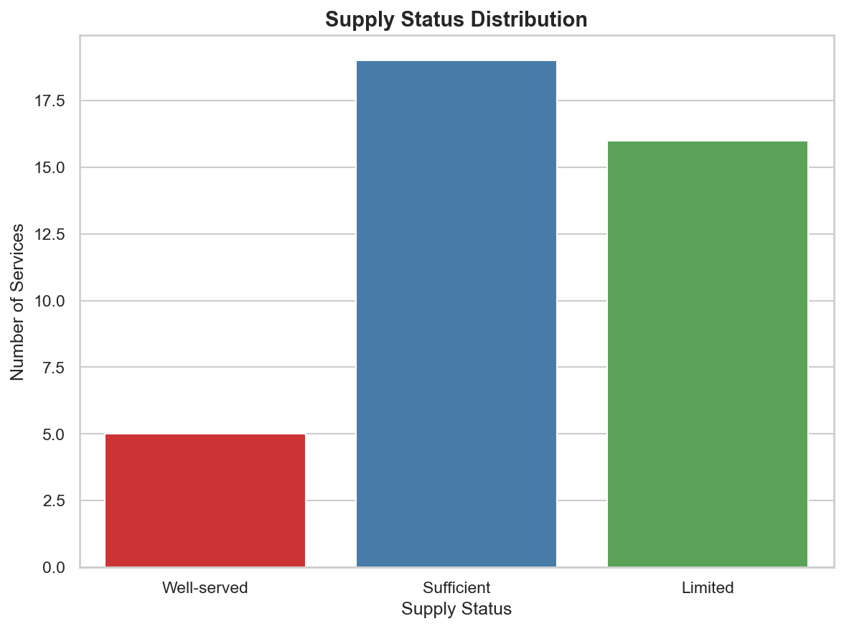
Figure 2: Supply Status Distribution
The chart above confirms that while Sufficient is the most common supply status, the combined share of Limited categories at 40% is substantial. This signals that a large portion of the home services market still lacks an adequate number of trained and accessible professionals.

5. Demand Level Analysis
Understanding which categories attract strong consumer demand is essential for identifying where workforce development efforts should be concentrated. The table below groups the 40 service categories by their assessed demand level.
Table 3: Service Categories Grouped by Demand Level
Demand Level | Services | Count
High | Deep Cleaning, Plumbing Repair, Electrical Repair, Carpentry, Washing Machine Repair, AC Services, Painting, Packing and Moving, Bridal Makeup, RO Water Purifying, CCTV Services, Modular Kitchen, Home Renovation, Salon at Home, Tiling, Handyman, Masonry Repair | 17
Medium | EV Charger Installation, AirBnB Maintenance, Refrigerator Repair, Pest Control, Spa at Home, Physiotherapy, Massage Therapy, Water Tank Cleaning, Aluminium Fabrication, False Ceiling, Computer Repair, Geyser Repair, Septic Tank Cleaning | 13
Low | Garden Care, Drywall Repair, Chef at Home, Home Automation, Parqueting, Indoor Planting, Chimney Repair, Tree Cutting and Pruning, Pet Grooming, Lift or Elevator Repair | 10

Key observations by demand level are as follows:
- High demand (17 categories): Plumbing Repair, Electrical Repair, Painting, and AC Services lead this group. These are the most active employment categories where most formal and platform-based workers are concentrated.
- Medium demand (13 categories): Computer Repair and CCTV Services benefit from strong platform-based delivery, while Physiotherapy and Spa at Home show growing consumer interest but lack an organized enough workforce to meet it reliably.
- Low demand (10 categories): Home Automation, Drywall Repair, and Indoor Planting have few providers and low consumer awareness, though some may grow as urbanization deepens and household preferences evolve.
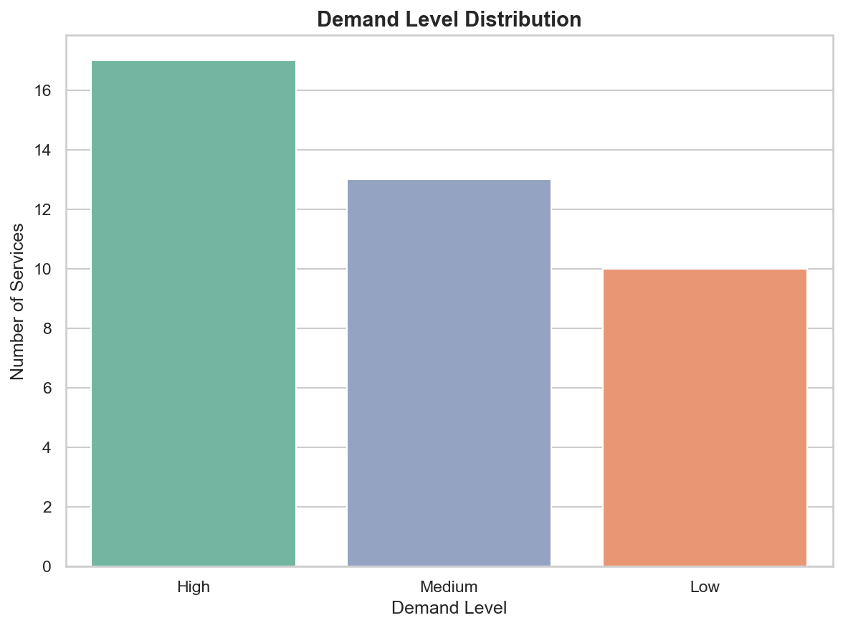
Figure 3: Demand Level Distribution
As seen in the chart above, High demand dominates across 17 of the 40 categories, followed by Medium at 13 and Low at 10. This distribution suggests the market has a strong base of established service needs alongside a growing middle tier of moderately demanded services.
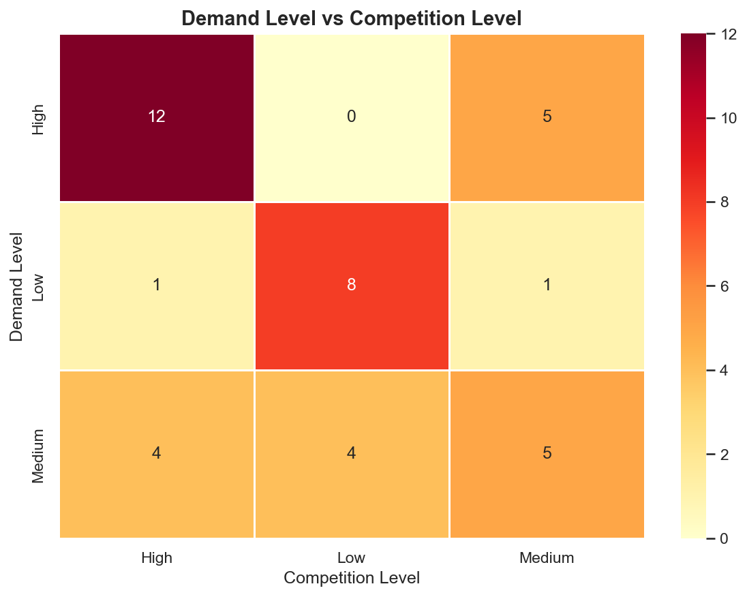
Figure 4: Demand Level vs Competition Level Heatmap
The heatmap above reveals that services with High demand almost exclusively fall into the High or Medium competition brackets, with no High-demand category showing Low competition. Conversely, 8 Low-demand services also show Low competition, confirming these are genuinely niche areas rather than overlooked opportunities.

6. Competition and Market Structure
Competition in the home services sector in Nepal is heavily concentrated in a small number of core trade categories. The competitive landscape across the 40 categories can be summarized as follows:
- High competition (17 categories): Services such as Plumbing Repair, Electrical Repair, Painting, Deep Cleaning, AC Services, Carpentry, and Modular Kitchen attract multiple providers including formal companies, apps, and platforms actively competing for the same customers.
- Medium competition (11 categories): Masonry Repair, RO Water Purifying, CCTV Services, Refrigerator Repair, and False Ceiling fall here. Some formal players have entered these markets, but consolidation is still ongoing.
- Low competition (12 categories): EV Charger Installation, AirBnB Maintenance, Drywall Repair, Home Automation, Chef at Home, Parqueting, Chimney Repair, Massage Therapy, Septic Tank Cleaning, Tree Cutting and Pruning, and Lift or Elevator Repair operate in largely uncrowded environments, representing entry opportunities for new providers.
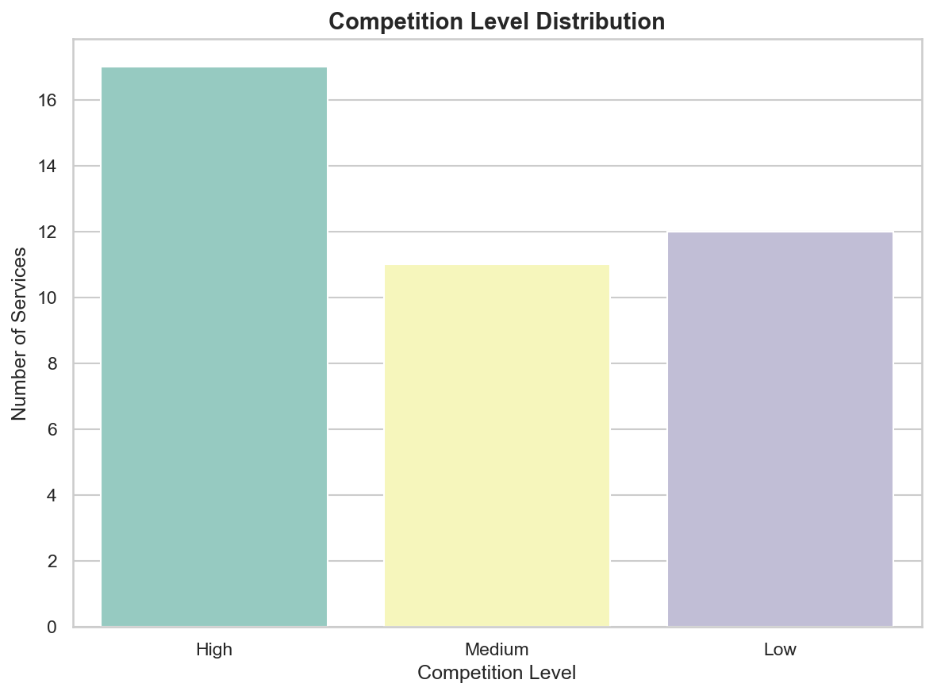
Figure 5: Competition Level Distribution
The chart confirms that High competition is the most common scenario across all 40 categories. However, Low competition is not far behind at 12 categories, indicating that nearly a third of all categories remain relatively uncrowded. This represents a meaningful window for new entrants to build a presence before these segments become saturated.

7. Workforce Formality and Platform Penetration
Three types of providers were identified across the 40 categories. Key patterns by provider type are as follows:
- Fully formal categories: AirBnB Maintenance, Drywall Repair, Home Automation, and Septic Tank Cleaning are served 100% by formal companies with no app-based or informal alternatives. This reflects the technical or institutional nature of these services, though in most cases only one or two providers exist.
- Platform-dominant categories: Computer Repair (78%), AC Services (57%), CCTV Services (56%), Carpentry (55%), Geyser Repair (60%), Electrical Repair (53%), and False Ceiling (57%) are led by app and platform-based providers. Technology-enabled platforms have effectively aggregated skilled workers in these sectors.
- Informality-dominant categories: Bridal Makeup (73% informal), Salon at Home (55% informal), and Parqueting (25% informal) rely heavily on word-of-mouth referrals and local directory listings rather than formal structures or apps.
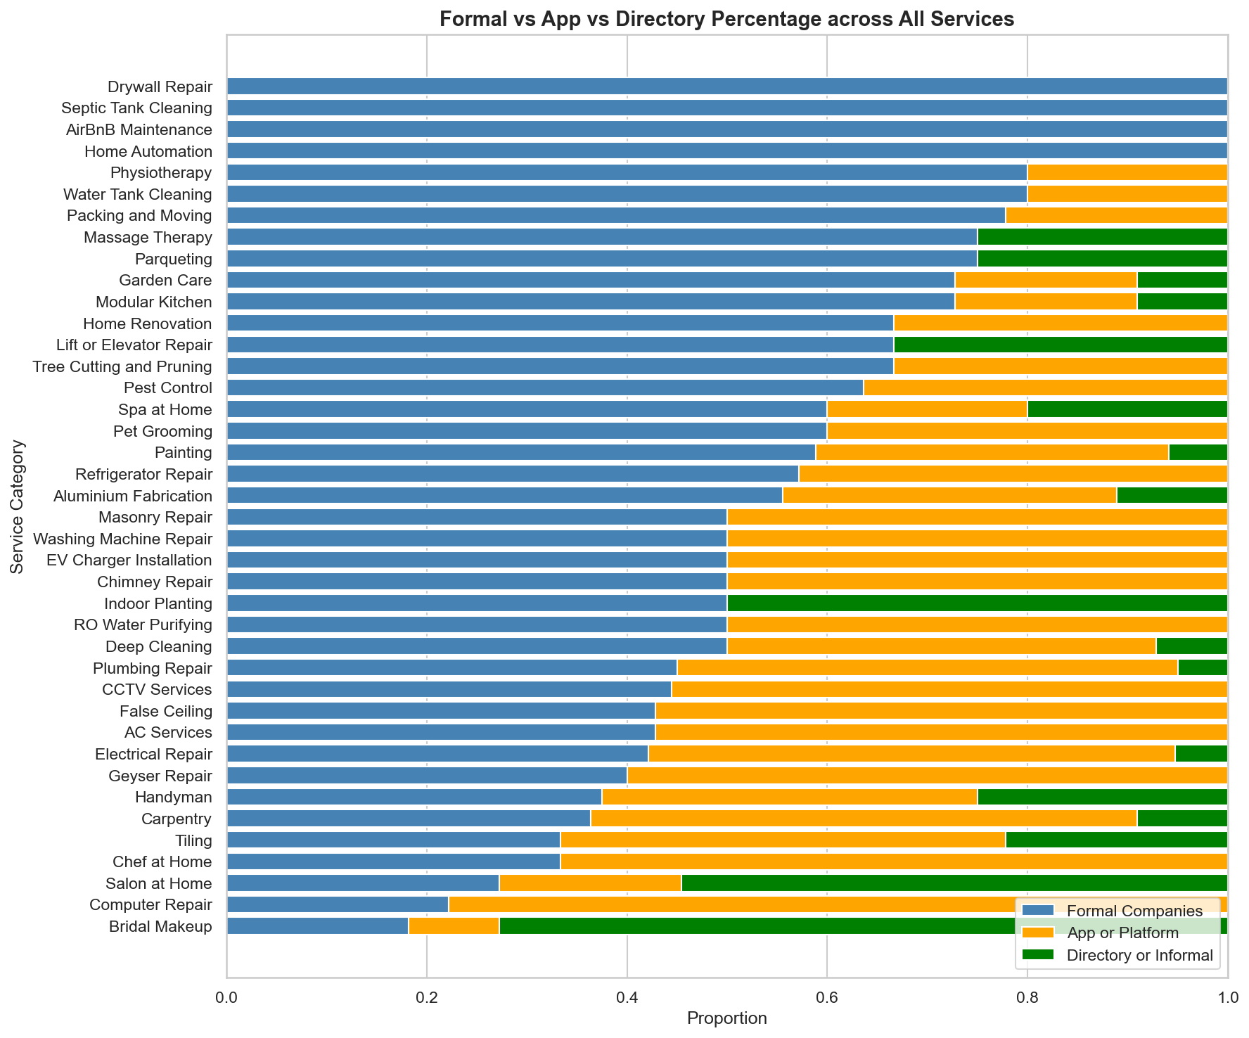
Figure 6: Formal vs App vs Directory Percentage across All Services
The stacked bar chart above illustrates the formality breakdown across all 40 service categories. Technical trade services lean heavily toward formal companies and app platforms, while personal care and lifestyle services carry a higher share of informal and directory-listed providers. This distinction has practical implications for quality assurance, worker protection, and consumer trust.

8. Workforce Gaps and Emerging Opportunities
This analysis reveals several clear gaps in the current home services workforce in Nepal. The most prominent gaps are in technically specialized or emerging categories where formal training and certification pathways are either absent or still developing. Key gaps identified are as follows:
- EV Charger Installation: Only 4 providers were identified despite the rapid growth of electric vehicles in Nepal. As EV adoption accelerates, demand for qualified installation technicians is expected to increase significantly and the workforce is currently not positioned to respond.
- Home Automation: Only 2 providers were found, both formal companies, with no app-based or informal alternatives. As smart home technology becomes more accessible, this gap will likely widen without targeted workforce development.
- Physiotherapy and Spa at Home: Both have only 5 providers each and are classified as Limited. Growing health awareness and an aging population suggest that demand for these home-based services may increase in the future.
- Chef at Home, Parqueting, and Indoor Planting: These lifestyle services show low demand and low competition but represent categories that are common in more mature on-demand service markets. With the right platform support, they have potential to attract new consumer segments.
- Pet Grooming: Urban pet ownership in Nepal has increased but the formal grooming workforce remains small, with only 5 providers identified.
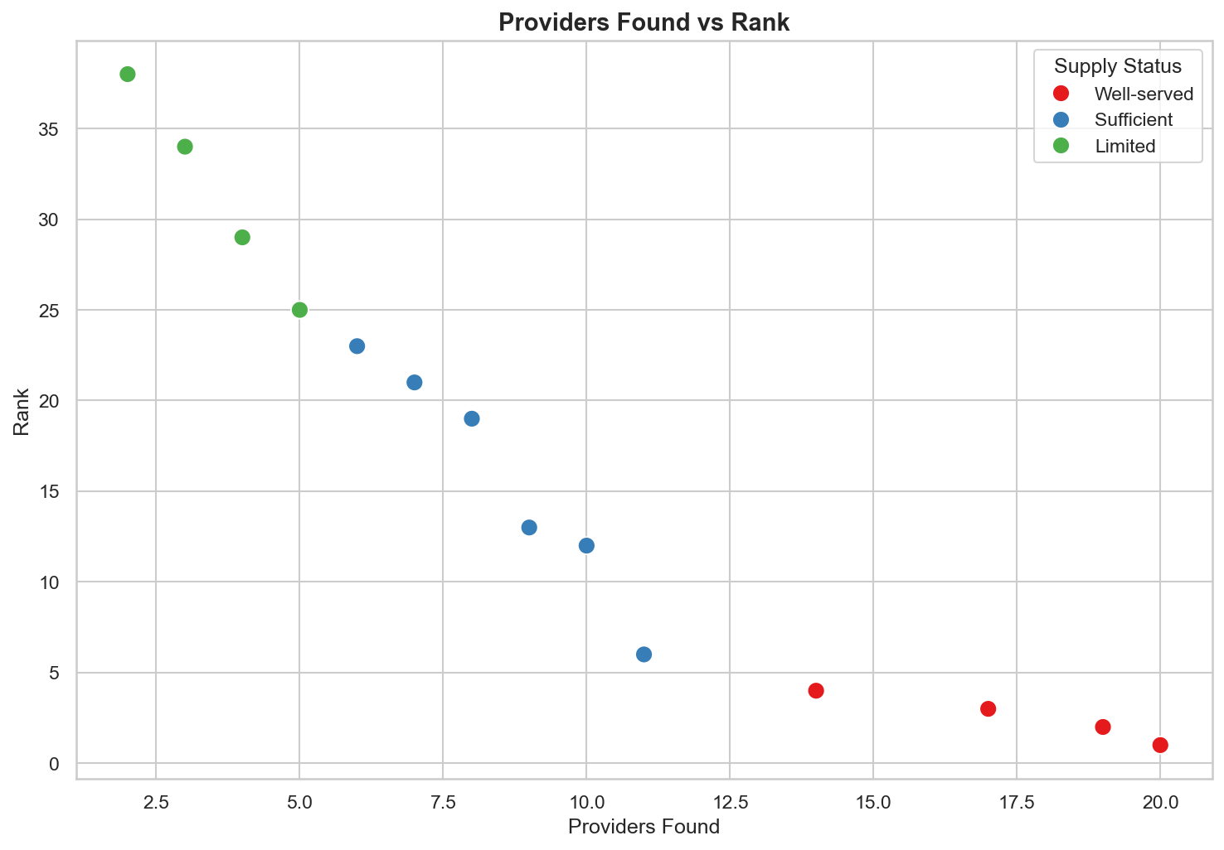
Figure 7: Providers Found vs Rank by Supply Status
The scatter plot above clearly illustrates the relationship between provider count and rank, colored by supply status. Well-served categories cluster in the bottom right, confirming that more providers lead to better competitive positions. Limited categories sit in the upper left, where few providers exist and ranks are poor. This visual reinforces the core finding of this section: the workforce gap is most acute precisely where the market needs more organized and accessible professionals.

9. Observations and Recommendations
Based on the data collected across the 40 categories, the following recommendations are directed at stakeholders in the on-demand home services sector:
- Invest in training and certification for technically specialized services such as EV Charger Installation, Home Automation, and Lift or Elevator Repair. These are areas where unqualified providers pose real risks to consumers, making formal certification particularly important.
- Expand platform-based aggregation to underserved categories such as Physiotherapy, Spa at Home, and Chef at Home. This can bring more informal practitioners into the formal economy while improving service discovery for consumers.
- Shift focus from supply expansion to quality assurance in Well-served categories such as Plumbing Repair, Electrical Repair, and Painting. With many providers already active, mechanisms for verifying credentials, collecting consumer feedback, and standardizing pricing would improve market functioning.
- Support formalization of personal care workers in categories such as Bridal Makeup and Salon at Home through basic business training, digital onboarding, and access to consumer-facing platforms. This would improve both earnings stability and service quality for workers in these segments.
- Explore emerging lifestyle categories including Chef at Home, Indoor Planting, and Pet Grooming as future growth areas. While demand is currently low, rising urbanization and changing consumer preferences suggest these segments are worth monitoring and nurturing with early platform support.

10. Conclusion
The workforce landscape across the 40 on-demand home service categories in Nepal reflects a market at different stages of development. A small but important group of categories are well-served by a competitive provider base. Most categories are adequately served but have room for quality improvement and deeper penetration. A significant number of categories, particularly in emerging and specialized fields, are underserved by the current workforce and present clear opportunities for investment in skill development, platform infrastructure, and formal workforce organization.
As urbanization continues and consumer expectations evolve, the demand for reliable, professionally delivered home services will only grow. Addressing the workforce gaps identified in this report is essential for ensuring that the on-demand home services market in Nepal can meet that demand effectively and equitably.

